7th grade School Supply List
To keep at home or in personal cubby:
Face mask and shield for each day at school (bring back-up face masks)
5+ pieces of poster board (to use throughout the year)
1 large multi-subject binder (4+ subjects)
1 package dividers with tabs
Basic or scientific calculator (personal)
4 college rule composition notebooks (needed for Social Studies and ELA)
1 engineering composition notebook (graph paper)
2 packages loose-leaf notebook paper (college-rule)
1 package graph paper
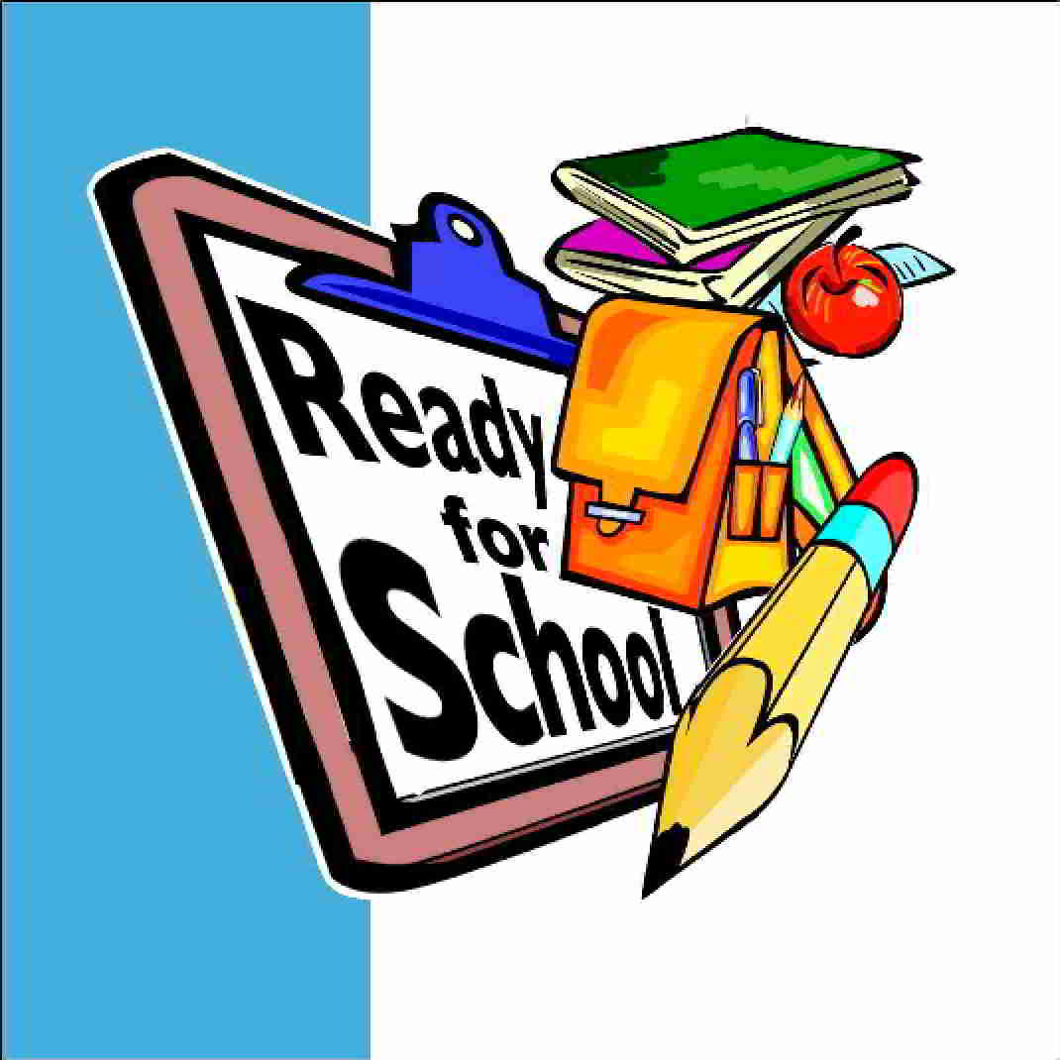
1 package 3x5 index cards
1 set earbuds or headphones and wireless mouse
1 pencil bag/pouch:
- Glue stick
- Colored pencils, markers
- #2 pencils
- Scissors
- Highlighters
- Handheld pencil sharpener

To Give to School Collection:
2 containers of Clorox wipes
Wish List
Printer ink cartridge: Brother TN-650

High quality, electric pencil sharpeners
Dry erase markers
Cardstock
Coffee Cups, Keurig pods, creamer

2 bottles of spray cleaner with bleach
2 bottles of hand sanitizer
3 boxes of tissue
3 reams of white copy paper
1 box Band-Aids (any size)
1 tube Neosporin (or equivalent)
1-2 packs of plastic plates
1-2 boxes of plastic forks and spoons

