Smoke Rise Prep 1St Grade 2020-21021
School Supply List
Please write your child’s name on all supplies because we will not be sharing.
1 Backpack and Lunchbox
5+ Cloth masks
1 Crayola crayons –24 pack
1 Crayola 8 or 10 count markers AND 12 count Crayola colored pencils
1 Scissors - Fiskars for Kids, 5” pointed tip
24 Pencils - #2 (pre-sharpened) Ticonderoga
1 Dry Erase Marker set (4 pack, Expo low-odor markers, chisel tip)
1 Large bottle Dry Erase spray cleaner
2 boxes Facial Tissues
1 Pencil box - plastic, see-through, big enough to hold glue, crayons, markers, scissors
2 Permanent Sharpie black markers
3 Pentel High Polymer Large White Erasers
2 Elmer’s Glue Sticks, large size
1 12” ruler with centimeter side
3 1st grade tablet paper pads
2 reams copy paper
2 rolls Blue Painter’s Tape
4 Box of Clorox Wipes (for cleaning desks during school day)
1 large bottle of hand sanitizer, 1 bottle of hand soap, and 1 bottle of spray cleaner with bleach
1 Computer headset/headphones- place in gallon size zip lock baggie, labeled with student name
1 wireless mouse for Chromebook
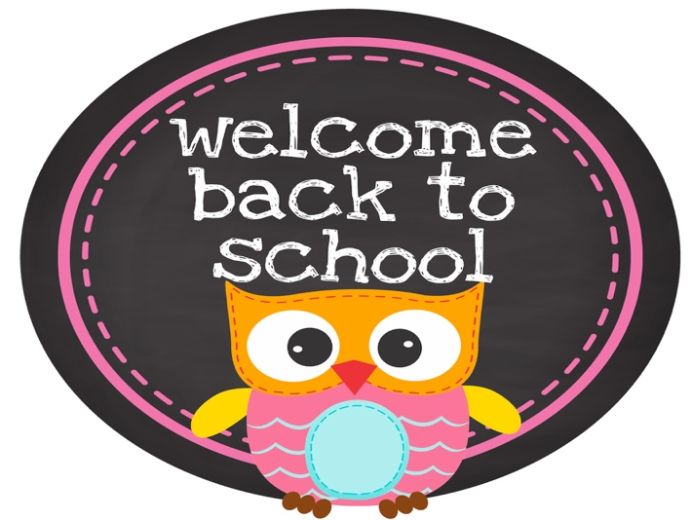
1 Box of children’s chewable Tylenol or Ibuprofen

3 Rolls of Paper Towels
2 Gel ice packs
2 Plastic utensils and paper plates
Wish List
Printer ink for Samsung M2830DW
Coffee cups, Keurig coffee pods, creamer

